PROBLEM- 1
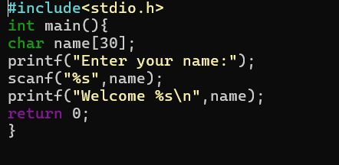

OUTPUT:

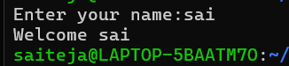

PROBLEM – 2
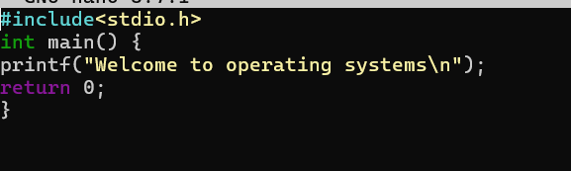
OUTPUT:


PROBLEM – 3
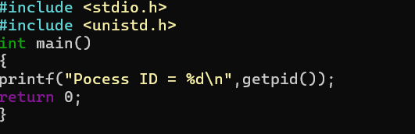

OUTPUT:
PROBLEM – 4

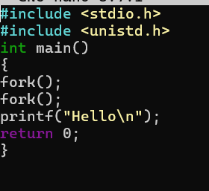

OUTPUT:

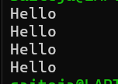
PROBLEM – 5

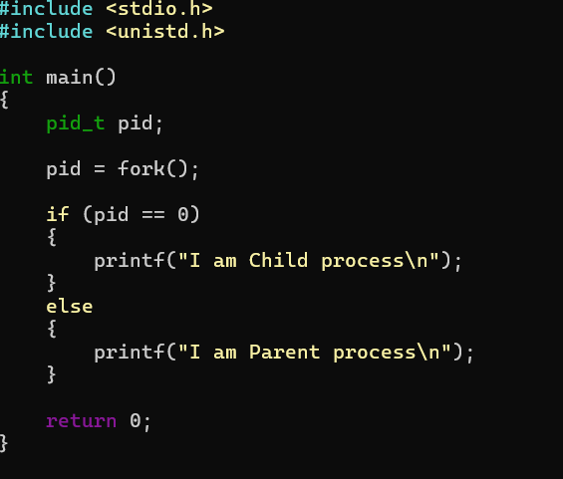

OUTPUT :

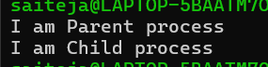

PROBLEM – 6

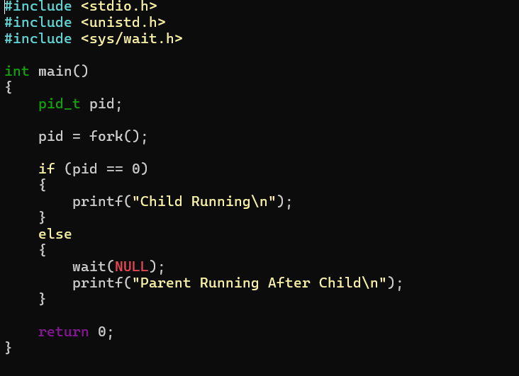

OUTPUT:



